## Get this graph in R/R Studio using the codes provided in the class slide of session 18:

library(plotly)

## Warning: package 'plotly' was built under R version 4.1.2

## Loading required package: ggplot2

##   
## Attaching package: 'plotly'

## The following object is masked from 'package:ggplot2':  
##   
## last_plot

## The following object is masked from 'package:stats':  
##   
## filter

## The following object is masked from 'package:graphics':  
##   
## layout

pop_mean <- 50  
pop_sd <- 5  
LL <- pop_mean-pop_sd  
Ul <- pop_mean + pop_sd  
x <- seq(-4,4,  
length=100)*pop_sd+pop_mean  
y <- dnorm(x,pop_mean,pop_sd)  
plot(x,y)  
  
  
abline(v= pop_mean, lwd = 2, col= "red")  
abline(v = 45, lwd= 2, col = "blue")  
  
abline(v = 55, lwd= 2, col = "blue")  
abline(v= pop_mean- 2*pop_sd, lwd= 2, col = "blue")  
abline(v= pop_mean+2*pop_sd, lwd= 2, col = "blue")  
abline(v= pop_mean- 3*pop_sd, lwd= 2, col = "blue")  
abline(v= pop_mean+ 3*pop_sd, lwd= 2, col = "blue")  
segments(x0 = 45,  
 x1 = 55,  
 y0 = 0.04,  
 lwd = 2,  
 col = "red")   
segments(x0 = 40,  
 x1 = 60,  
 y0 = 0.01,  
 lwd = 2,  
 col = "red")  
segments(x0 = 35,  
 x1 = 65,  
 y0 = 0.00,  
 lwd = 2,  
 col = "red")  
   
text(x=x[50], y=0.04, labels= '67%' )  
text(x=x[50], y=0.01, labels= '95%' )  
text(x=x[50], y=0.00, labels= '99%' )

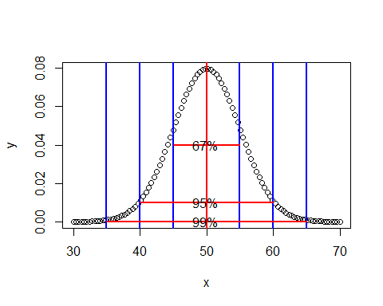 ## Get stem-leaf plot, histogram and normal q-q plot of mpg variable of the built-in “mtcars” data of R.

data = data.frame(mtcars)  
stem(data$mpg)

##   
## The decimal point is at the |  
##   
## 10 | 44  
## 12 | 3  
## 14 | 3702258  
## 16 | 438  
## 18 | 17227  
## 20 | 00445  
## 22 | 88  
## 24 | 4  
## 26 | 03  
## 28 |   
## 30 | 44  
## 32 | 49

From above plot we can see that mininum 28 mile per gallon fuel is consumed and maximum of 143702258 mile per gallon fuel is consumed.

breaks <- seq(10, 35, by=5)   
mpg.bin <- cut(as.vector(data$mpg), breaks,  
labels = c("10-15", "15-20", "20-  
25", "25-30", "30-35"))  
freq <- table(mpg.bin)  
hist(freq, main = "Histogram ofmpg variable")

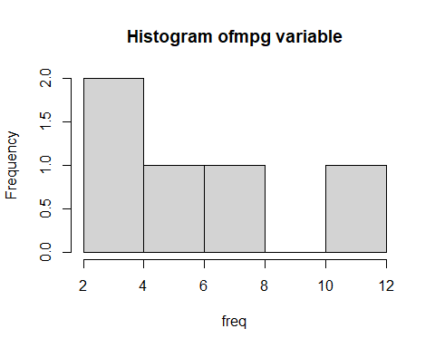

qqnorm(data$mpg)  
qqline(data$mpg)

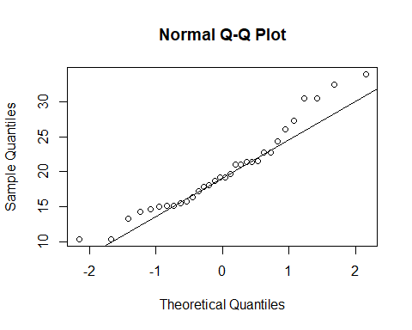 The points seem to fall about a straight line. X-axis plots the theoretical quantiles. Those are the quantiles from the standard Normal distribution with mean 0 and standard deviation 1.

## Test the normality of mpg variable of mtcars data using Shapiro-Wilk test of normality and take decision based on the p-value of this test for null and alternative hypothesis you wrote for this test. Explain why this test of normality must be used here!

shapiro.test(data$mpg)

##   
## Shapiro-Wilk normality test  
##   
## data: data$mpg  
## W = 0.94756, p-value = 0.1229

Here p value is 0.1229 which is grater then 0.05 hence our null hypothesis is accepted. Shapiro-Wilk test may be suitable for smaller samples of data, e.g. thousands of observations or fewer so it is suitable for mtcars.